Pneumonia & Chronic Bronchitis

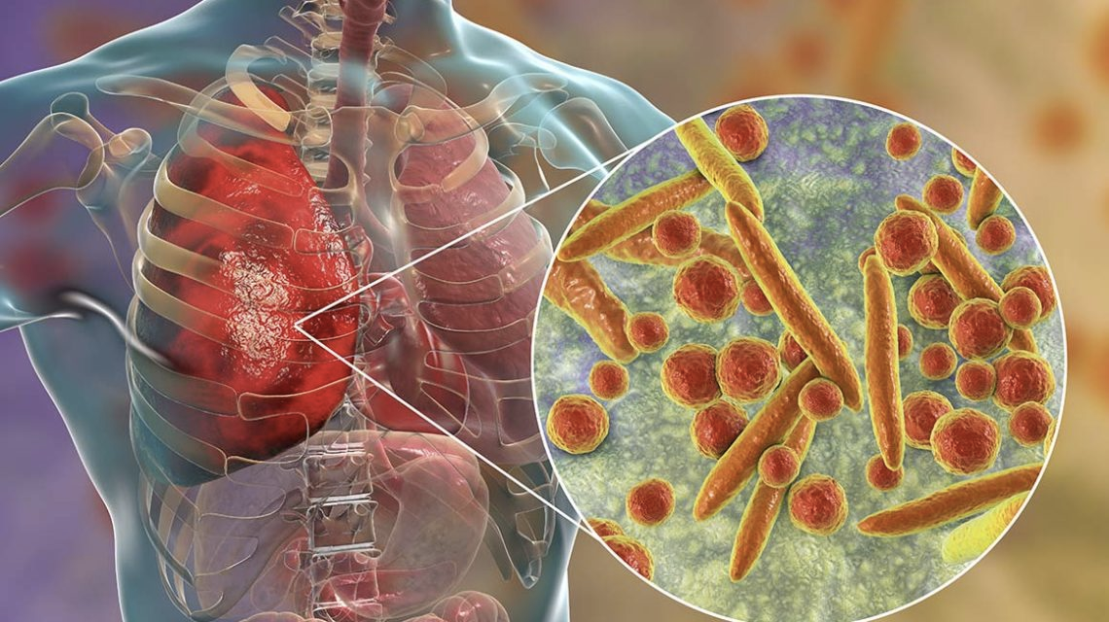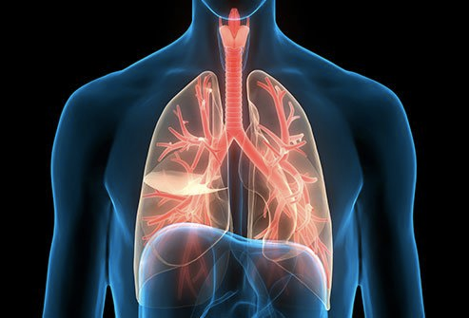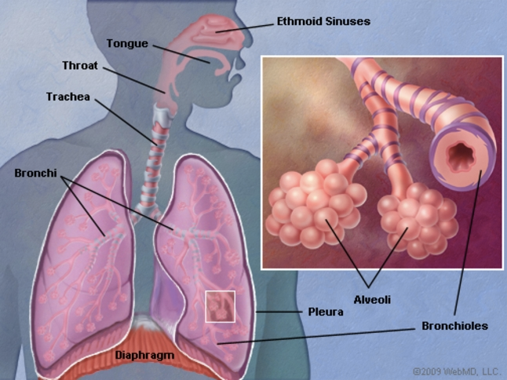

Pneumonia & Chronic Bronchitis

Pneumonias:

Causes?

Pneumonia are often unfold through breathing infected droplets within the air from a cough or sneeze of AN infected person. The infection also can be unfold through blood (e.g. throughout birth). It are often triggered by a chilly or bout of the contagion, that permits germs to grow within the air sacs of the lungs. The infection will develop in only 1–3 days.

Symptoms?

Pneumonia symptoms will vary from thus delicate you barely notice them, to thus severe that medical care is needed. however your body responds to respiratory illness depends on the kind germs inflicting the infection, your age and your overall health. They find this by X-raying your lungs to look for inflammation.

symptoms of respiratory illness will include:

Coughing , which can turn out chromatic, yellow or maybe bloody mucous secretion,Fever, Shortness of breath, Rapid, shallow respiration, Sharp or stabbing hurting that gets worse after you breathe deeply or cough, Loss of appetence, low energy, and fatigue, Nausea and inborn reflex, particularly in young children, Confusion, particularly in older folks

symptoms could vary in bound populations. Newborns and infants might not show any signs of the infection. Or, they'll vomit, have a fever and cough, or seem restless, sick, or tired and while not energy. additional seasoned adults and people United Nations agency have real diseases or weak safe frameworks could have fewer and milder facet effects. they'll even have a below traditional temperature. undergone adults United Nations agency have respiratory illness currently and once more have surprising changes in mental awareness. for people that have already got a persistent respiratory organ sickness, those facet effects could worsen.

Treatments?

When you receive a respiratory illness identification, your medico can work with you to create up a treatment set up. medical aid for respiratory illness depends on which sort of respiratory illness you have got, sick you're feeling, your age, and whether or not you have got alternative medical problems. The goals of treatment area unit to repair the sickness and forestall difficulties. it's vital to follow your treatment set up cautiously till you're fully recovered.Typical antibiotics don't work against viruses. If you have got pneumonia, your doctor could inflict AN antiviral medication to treat it.

Drink heat beverages, take sticky baths and use a humidifier to assist open your airways and ease your respiration.

Stay away from smoke to let your lungs heal. This includes smoking, secondhand smoke and wood smoke.

Drink lots of fluids to assist loosen secretions and produce up phlegm.

And bear in mind to urge loads of rest

If the respiratory illness is severe, you may ought to head to the hospital and If you head to the hospital you may get: atomic number 8 treatment, IV fluids and medications, Treatments to assist slow down the mucus/gunk

Preventions?

2 protected shots from respiratory illness that is that the PCV13 (Prevnar 13) and also the PPSV23 (Pneumovax) looking on your case history and age. Besides the shot here are other ways in which to protect yourselves from the disease: Wash your hands frequently, particularly once you head to the toilet and before you eat, To exercise and to eat healthy with lots of vegetables, to urge enough sleep, reducing either stress, to remain off from smokers and sick folks (infected)

Chronic Bronchitis:

Causes?

Cigarette smoking is out and away the No. one explanation for bronchitis. quite ninetieth of individuals with the sickness smoke or accustomed smoke. alternative things that raise your probabilities for it include: Secondhand smoke, Dust

Certain fumes, like hairspray if you're employed in an exceedingly hair salon or house paint if you’re a building contractor, pollution, attachment fumes, engine exhaust, Coal, fire smoke

Women get diagnosed with bronchitis quite men do. most of the people United Nations agency have the sickness area unit forty four to sixty five. bronchitis could build it less complicated for you to urge metabolism contaminations like bugs, seasonal respiratory illness, and respiratory illness.

Symptoms?

Chronic bronchitis fills your lungs with phlegm/mucus. the limited hairs that usually move mucous secretion out of your lungs area unit injured. that produces you cough/wheeze. because the sickness goes on, it's tougher for you to inhale.

Other signs of bronchitis could include:

Cough, typically with mucous secretion

Wheezing

Tight chest

Shortness of breath

Feeling tired

Symptoms could vary thanks to the weather and temperature.Tests used to diagnose chronic bronchitis include pulmonary function tests, chest X-rays or CT scans.

Treatments?

If you smoke, you'd presumably ought to quit. Your lungs won't totally recover, however the speed of decline are abundant slower.

Other treatments include:

Airway openers (bronchodilators): area unit varieties of medicine that relax your airways to create it easier to inhale and exhale.

Anti-inflammatory drugs: Steroids reduce the swelling that narrows your air passages.

And if your lungs have very been destroyed due to this sickness it's seemingly they'd need a transplant.

Preventions?

Since smoking causes most cases of bronchitis, the most effective thanks to stop it's to not smoke. it is also necessary to do to avoid respiratory organ irritants like secondhand smoke, pollution, chemical fumes, and dusts. To continually wash your hand once consumption or handling dirty things, carrying masks in space with high pollution.

References:

<https://www.medicalnewstoday.com/articles/8888#symptoms>

<https://www.atsjournals.org/doi/full/10.1164/rccm.201210-1843CI>